Functions containing no free variables are pure.

() => {}

(x) => x

Function containing one or more free variable is called a closure.

(y) => x

(function (x) => {

function test(y) {

return x + y // x is a free variable

}

return test(3)

})(5)

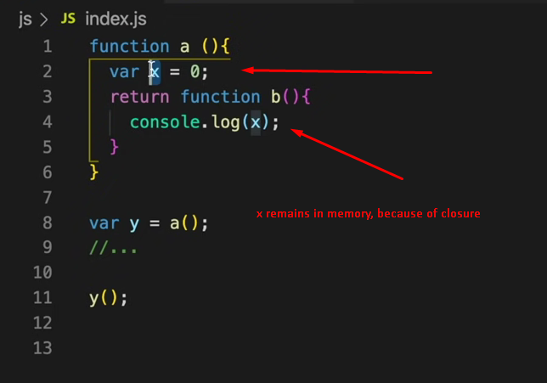

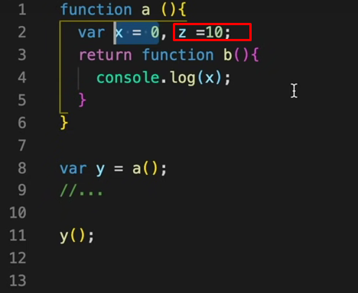

But here z will be cleared because there is no reference for it